Observed Faults in the Fischertechnik Learning Factory Demonstrator
Download the factory components manual for a better idea of the components, see: https://www.fischertechnik.de/en/industry-and-universities/technical-documents/simulate/training-factory-industry-4,-d-,0-24v
Additional context: in contrast to the Fischer Technik learning factory found on the internet we have the version with a Turck PLC and HMI that is steered by codesys. By default, no RPi or TXT controller.
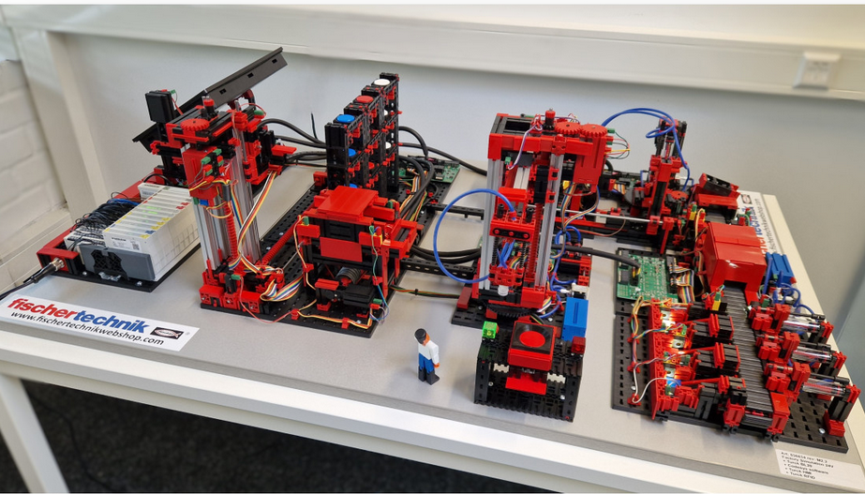

Installation and Preliminary Operation
During the installation and early operation of the Fischertechnik Learning Factory, deployed, multiple faults were observed. This document records these issues in a structured manner so they can be reused later for analysis, data collection, and predictive maintenance research. The faults described here emerged naturally during installation and early use, making them particularly valuable as realistic examples rather than artificially induced failures.
The factory was delivered pre-assembled and accompanied by a two-hour on-site workshop. This workshop was conducted by one representative from ShoppenTotaal, the Dutch supplier of Fischertechnik, and one representative from Turck, the company responsible for the PLC integration and control software. A substantial portion of this workshop was spent resolving faults, as various mechanical and control issues appeared sequentially. While unexpected for a system of this scale and cost, this behavior demonstrated that faults occur easily, and often, which is relevant for the intended predictive maintenance demonstrator.

Definition of Failure
For the scope of this demonstrator, a failure is defined as any state in which the machine cannot complete its intended production cycle safely or correctly. This includes situations where cargo(see image below) is not picked up, is dropped unintentionally, is not detected by a photo transistor (missing cargo), or is placed in the wrong location. Failures also include software-related issues such as the machine becoming stuck in a loop, entering an abortive state, encountering timeouts, or executing an incorrect process flow. Finally, any situation that requires manually powering down the machine to avoid mechanical damage is considered a failure, for example when parts are loose, misaligned, or at risk of colliding.
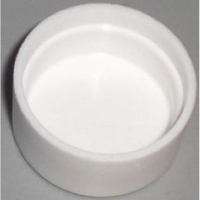
Figuur 1 Cargo (workpiece, top and bottom). Inside an RFID chip containing the color information is placed.

Calibration and Accuracy
The most frequently occurring problems were related to calibration and positioning accuracy, particularly involving the main robot arm. The robot arm is driven by a motor that can only be controlled in an on-or-off manner. Positioning is achieved by hardcoding a specific number of motor encoder clicks in the PLC logic. In theory, each click corresponds to a fixed angular or linear displacement; however, in practice this assumption does not hold reliably.
Repeated movements using the same number of clicks resulted in variation in the final position of the robot arm. Even a difference of one or two clicks could lead to a positional offset. We are still unsure how accuracte or how much variation there is between diplacement and clicks. Since all click values are hardcoded and global, small deviations accumulate across the system and propagate into downstream process steps.
Because the system lacks continuous position feedback, it relies heavily on reset buttons or limit switches. Components are frequently commanded to move until a reset button is physically triggered, which is the only way the system determines that a known reference position has been reached. In several observed cases, reset buttons were not triggered when expected for example when not reaching the reset button in the amount of specified clicks. When this happened, the system either failed to continue or proceeded with an incorrect internal state, as the true position of components was unknown.

Robot Arm Miscalibration and Failure Points
During installation, the robot arm appeared to be miscalibrated. This miscalibration did not seem to be random but rather related to incorrect hardcoded values used for motor movements. Within a single complete production cycle, the robot arm performs several critical actions, each of which can fail due to mispositioning. These include picking up cargo from the warehouse, placing it on the RFID delivery bay, transferring it to the furnace area, retrieving color-identified cargo, and finally returning cargo to the warehouse. Failure at any of these stages typically results in dropped cargo, missed pickups, or unsafe interactions.
The root cause of this miscalibration is not fully known. A likely explanation is the absence of a machine-specific calibration step during manufacturing or commissioning. Since the system relies on fixed values, even small differences in component mounting positions can result in systematic errors. Additionally, the control logic does not reason about misalignment. When the robot arm misses its intended position, the process is not always aborted safely. In some cases, the arm continued its motion and pushed cargo forcefully into other components, risking serious mechanical damage.

Lubrication
Another potential source of faults is insufficient lubrication. The machine contains multiple moving elements such as gears, spinners, and rails. These components are assumed to move freely without friction in the control logic. If lubrication is inadequate, friction increases and motors must exert more effort to achieve the same movement. This can effectively change the relationship between motor clicks and actual motion, resulting in further miscalibration.
At the time of writing, no lubrication-related faults have been directly observed. However, there is currently no way to distinguish these faults from other calibration issues should they occur. This makes lubrication problems an important but currently unobservable failure mode.

Warehouse Configuration and Misplaced Parts
The machine is designed to process three colors: red, white, and blue. In the nominal starting state, all pieces(nine in total, three per color)must be placed in the warehouse in a predefined configuration. Each color must be correctly arranged according to the intended row-and-column logic of the warehouse layout. In addition, each piece is placed inside a cargo carrier (workpiece carrier), as shown in Figure 2.
During the installation workshop, several configuration errors occurred. Cargo pieces were placed in the wrong color order, and in some cases the orientation logic was incorrect, with colors arranged per row rather than per column. When this happens, the warehouse may pick up an incorrect color without any immediate detection. The fault only becomes visible once the part reaches the RFID scanner or the color processing station in the delivery area.
The tracking of which colors are present in the warehouse is currently hardcoded. When an incorrect color is picked, this state is not corrected later, even if the mismatch is detected downstream. Consequently, the system continues operating under an incorrect internal representation of the warehouse state, allowing logical errors to propagate through the remainder of the production cycle.
An additional, safety-critical fault occurs when a cargo carrier is placed in the warehouse facing the wrong direction. The carrier is handled similarly to a pallet. Because the carrier is not symmetrical, an incorrect orientation can cause the warehouse picker or pallet-like mechanism to push forcefully against the carrier. In observed cases, this resulted in the entire warehouse module being pushed, which poses a significant risk of mechanical damage.
Another related issue is the placement of empty cargo carriers. If a carrier without cargo is placed in the warehouse, the system will successfully complete the warehouse handling cycle and the robot arm will attempt to pick up and place a non-existent part in the delivery area. This fault is only detected at the delivery area, where rfidsensors confirm the absence of cargo. A photo-transistor is present at the end of the warehouse, but it only detects whether a carrier is present, not whether the carrier contains cargo.
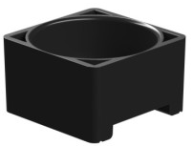
Figuur 2 Cargo (workpiece) carrier/pallet. As you can see it is not symmetrical!

Loose and Misaligned Parts
Loose or misaligned mechanical components were a recurring problem, particularly during the initial workshop. While some of these issues may have been introduced during transport or installation, it is unclear to what extent they may continue to emerge during regular operation.
One example involved the delivery area, which was slightly misaligned due to movable feet. This issue was initially interpreted as a calibration problem but later identified as a purely mechanical misalignment. Loose gears were another frequent issue; when gears were not firmly attached, motion became inconsistent or stopped entirely. In addition to preventing motion, loose gears introduce backlash, which degrades positional accuracy and can worsen progressively over time.
Parts of the warehouse itself also became loose during the two-hour workshop. In particular, poor fitting between the motor, gear, and stepper rail caused the carrier picker to miss its intended position. Despite failing to reach the correct pickup location, the system continued attempting to pick cargo, resulting in forceful mechanical interactions. In extreme cases, the carrier picker pushed hard into the delivery bay, which not only risks mechanical damage but can also loosen nearby electrical connectors.
I will add photos of specific parts which came "loose" later!

Pneumatics and Compressor
The machine makes extensive use of pneumatic components, including a compressor, solenoid valves, pneumatic cylinders, and suction cups. These are responsible for generating the suction and pressure required to lift and push cargo. At present, the system has no sensors to directly measure pressure or vacuum levels.
During testing, several faults were caused by loose pneumatic tubes connecting the compressor, valves, and cylinders. When air leakage occurred, cylinders were unable to generate sufficient suction or pressure, causing the cargo not to be picked up or pushed. The system could not detect this condition explicitly. Furthermore, misalignment can prevent the suction cup from sealing correctly against the cargo. In such cases, suction never builds up, but the control system cannot differentiate this from a purely mechanical or control-related fault.

Electrical Connectors
The demonstrator contains a large number of electrical cables and connectors linking sensors, actuators, and the PLC. Several faults were caused by connectors becoming loose, resulting in lost signals. These failures can manifest in unpredictable ways and are often difficult to trace without dedicated diagnostics.

Other things that can happen
In addition to the photo transistors, which are currently the only means of detecting whether the cargo is delivered to the correct station, each cargo item contains an RFID chip. The delivery platform is able to detect and read this RFID. The chip stores information about the color of the picked up part.
If the cargo is not picked up correctly or is dropped during transport, this is not detected by the current system state. As a result, the platform may continue operating under the assumption that the delivery was successful, even though the cargo is missing or incorrect. The only method to measure this currently are the phototransistors put in most beginning or ends of the main stations.
List is not complete yet.

Likely Causes
Many of the observed faults are likely related to machine movement during transportation or installation. Vibrations and handling can loosen mechanical parts, misalign components, and stress electrical connections. It is not yet clear how frequently such issues arise during normal operation.
